dik



dun



minder

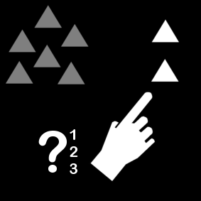

meer

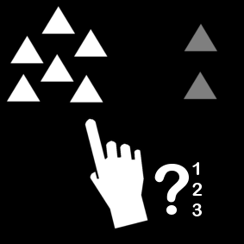

kleiner

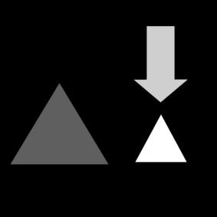

groter

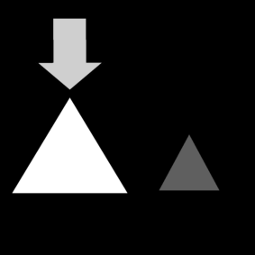

na

C:\Documents and Settings\thuis\Local Settings\Temporary Internet Files\Content.IE5\YB1YC204\MC900232988[1].wmf

voor

C:\Documents and Settings\thuis\Local Settings\Temporary Internet Files\Content.IE5\YB1YC204\MC900232988[1].wmf

laatste

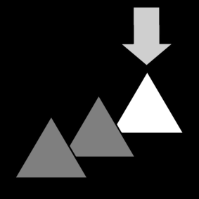

eerste

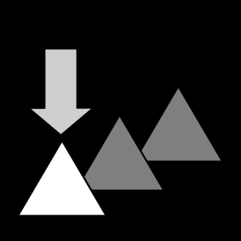

C:\Documents and Settings\thuis\Local Settings\Temporary Internet Files\Content.IE5\YB1YC204\MC900030371[1].wmf

onder

C:\Documents and Settings\thuis\Local Settings\Temporary Internet Files\Content.IE5\YB1YC204\MC900030371[1].wmf

op

C:\Documents and Settings\thuis\Local Settings\Temporary Internet Files\Content.IE5\BIWGF3I5\MC900355675[1].wmf

tussen

C:\Documents and Settings\thuis\Local Settings\Temporary Internet Files\Content.IE5\BIWGF3I5\MC900355675[1].wmf C:\Documents and Settings\thuis\Local Settings\Temporary Internet Files\Content.IE5\BIWGF3I5\MC900355675[1].wmf

naast

|  |  |
| --- | --- |
| optellen, plus, vermeerderen, bijdoen, som | + |
| aftrekken, min, verminderen, wegdoen, verschil | - |
| vermenigvuldigen, keer, maal, product | X |
| delen, verdelen, gedeeld door, quotiënt | : |

|  |  |
| --- | --- |
| dubbel, x2, 2 keer | C:\Documents and Settings\thuis\Local Settings\Temporary Internet Files\Content.IE5\PPLDPIQZ\MC900336122[1].wmfC:\Documents and Settings\thuis\Local Settings\Temporary Internet Files\Content.IE5\PPLDPIQZ\MC900336122[1].wmf |
| helft, : 2, verdelen in 2 | C:\Documents and Settings\thuis\Local Settings\Temporary Internet Files\Content.IE5\PPLDPIQZ\MC900336122[1].wmf |
| meer dan | + |
| minder dan | - |
| vorig |  |
| volgend |  |

|  |  |
| --- | --- |
| eenheden (E) | 1,2,3,4,5,6,7,8,9 |
| tientallen (T) | 10,20,30,40,50,60,70,80,90 |
| honderdtallen (H) | 100,200,300,400,500,600,700,800,900 |
| duizendtallen (D) | 1000, 2000, 3000,4000,5000,6000,7000,8000,9000 |

|  |  |  |  |  |  |  |
| --- | --- | --- | --- | --- | --- | --- |
| maandag | dinsdag | woensdag | donderdag | vrijdag | zaterdag | zondag |
| maandag | dinsdag | woensdag | donderdag | vrijdag | zaterdag | zondag |

|  |  |  |  |  |  |
| --- | --- | --- | --- | --- | --- |
| liter | maatbeker / litermaat   |  |  |  |  | | --- | --- | --- | --- | | l | dl | cl | ml | |
| kilogram | C:\Documents and Settings\thuis\Local Settings\Temporary Internet Files\Content.IE5\BIWGF3I5\MC900292574[1].wmf   |  |  |  |  | | --- | --- | --- | --- | | kg |  |  | g | |
| meter | meetlat   |  |  |  |  |  |  |  | | --- | --- | --- | --- | --- | --- | --- | | km | 100m | 10m | m | dm | cm | mm | |

|  |  |
| --- | --- |
| driehoek |  |
| vierhoek |  |
| vijfhoek |  |
| cirkel |  |
| recht |  |
| gebogen |  |

Bron afbeeldingen:  
http://www.sclera.be/  
http://office.microsoft.com/nl-nl/images/results.aspx?qu=lezen&ex=1#ai:MC900232988|  
http://office.microsoft.com/nl-nl/images/results.aspx?qu=taart&ex=1#ai:MC900336122|mt:1|  
http://office.microsoft.com/nl-nl/images/results.aspx?qu=weegschaal&ex=1#ai:MC900292574|